CS 255 System Design Document Template

This template lays out all the different sections that you need to complete for Project Two. Each section has guidance to prompt your thinking. You will need to continually reference the interview transcript as you work to make sure that you are addressing your client’s needs. There is no required length for the final document. Instead the goal is to complete each section based on what your client’s needs are. Remove this note when you are finished, and replace all bracketed text with the relevant information.

UML Diagrams

UML Use Case Diagram

UML Activity Diagrams
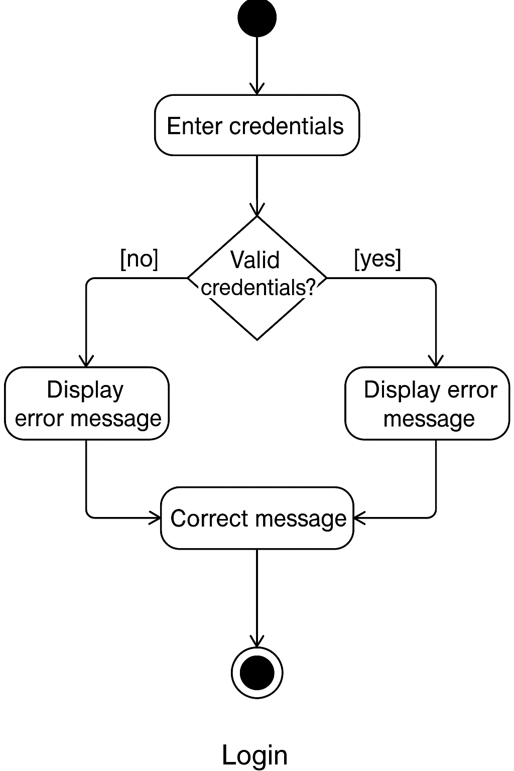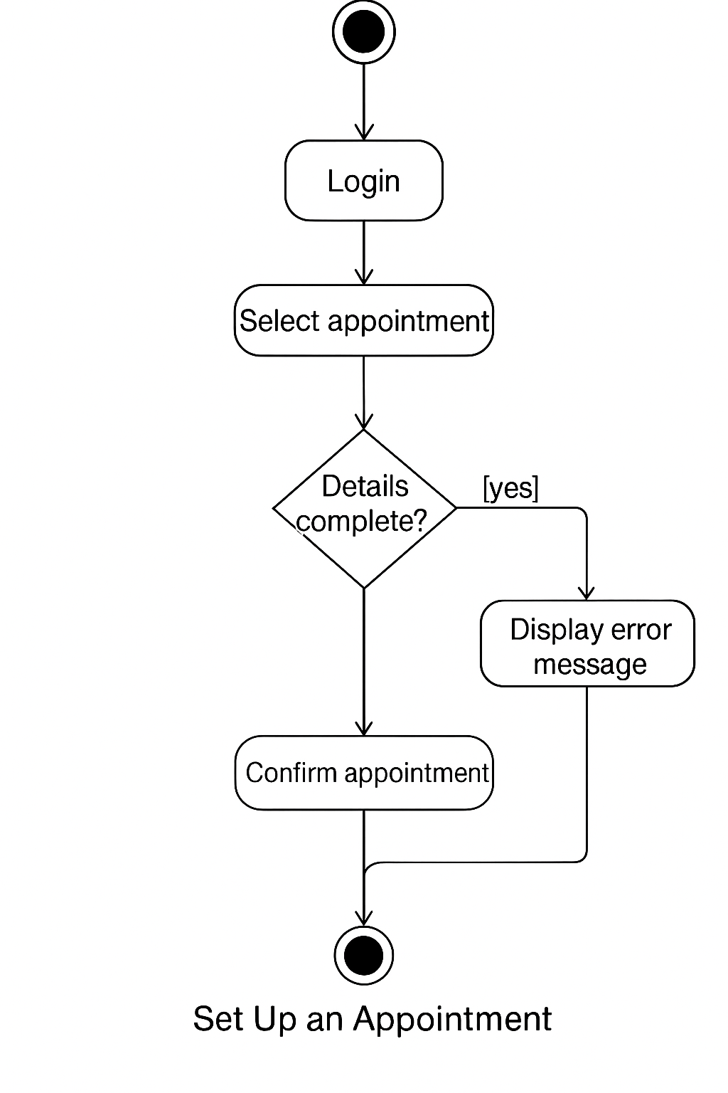

UML Sequence Diagram

UML Class Diagram

Technical Requirements
Hardware Requirements:
- Web server with sufficient RAM/CPU for handling concurrent users
- Database server with high-availability support
Software Requirements:
- Backend: Node.js / Python (Django or Flask) / Java (Spring Boot)
- Frontend: React / Angular / Vue
- Database: PostgreSQL / MySQL / MongoDB
- Authentication system: OAuth2 / JWT-based auth
- Reporting tool integration: JasperReports / Power BI
Tools:
- UML Modeling Tool: Lucidchart, StarUML, or Visual Paradigm
- CI/CD: GitHub Actions, Jenkins
- Code repository: GitHub / GitLab
Infrastructure:
- Cloud-based deployment using Docker/Kubernetes
- HTTPS enabled via SSL
- Backup and recovery strategy
- Monitoring tools (e.g., Grafana, Prometheus)

